VISVESVARAYA TECHNOLOGICAL UNIVERSITY
"Jnana Sangama", Belagavi - 590 018
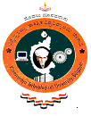

A Technical Seminar Report on

Generative AI Meets Traditional NLP: A Hybrid Approach for Robust Text Generation and Analysis

A Technical Seminar work submitted in partial fulfillment of the requirement for the award of the degree

Bachelor of Engineering
in
Computer Science and Engineering

Submitted by

ANISH KUMAR 1AY21CS028

Under the Guidance of
Prof. Sneha N P
Assistant Professor, CS&E
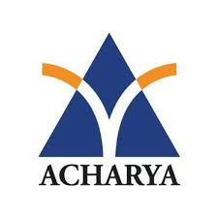
DEPARTMENT OF COMPUTER SCIENCE AND ENGINEERING
ACHARYA INSTITUTE OF TECHNOLOGY
(AFFILIATED TO VISVESVARAYA TECHNOLOGICAL UNIVERSITY, BELAGAVI, RECOGNISED BY AICTE, NEW DELHI)
Acharya Dr. Sarvepalli Radhakrishnan Road, Soldevanahalli, Bengaluru - 560107

2024-2025

